Zenlike: Balancing Fitness, Diet and Mindfulness

Project Proposal

Name: Steven Gaynor

Student Number: 14108038

Email: [x14108038@student.ncirl.ie](mailto:x14108038@student.ncirl.ie)

Higher Diploma in Science in Cloud Computing (HDCLOUD)

February 2015

# Zenlike: Project Proposal

## Objectives

For my project, I have decided to develop a website, and perhaps an app that integrates fitness, diet and the philosophy of mindfulness. There are many potential benefits to be derived from an API that can help the modern person plan their mindful life. There are of course many apps out there that allow the user to plan and monitor their fitness and diet, but not one that combines three important life disciplines into one package.

## Background

For this reason, I have come up with the idea of a potential website or app called *Zenlike.* The name of this package derives from the notion that a person has a “Zen-like calm about them”. So then, how can we make everybody have a Zen-like calm, yet also be well prepared for the stresses and strains of modern Western society? Well, the answer lies in giving power to the user to manage how they can apply centuries-old philosophies of mindfulness to their own lives. Primarily, it is envisioned that this balance would be achieved by planning and monitoring meditations, healthy diet and a course of bespoke physical exercise that fits in with their lives.

At a highly conceptual level, the overall vision of *Zenlike* is that of being a one-stop shop for doing all of these things and potentially more. The use case diagram on the following page explains the model of how the user will interact with the package.

In terms of potential marketability of the product, it’s clear that there is a large potential audience for this given the recent upsurge in interest in healthy living and lifestyle websites and mobile applications.

### Use Case Diagram

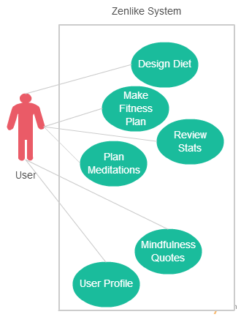

## Technical Approach

In terms of the technical approach to this project, the use cases of *Zenlike* will require the following elements of functionality:

* Choose from healthy foods from a list to work into your diet and attempt to get your recommended daily amounts of vitamins and essential minerals
* Design a fitness plan that fits around a busy life, involving a calendar and reminders
* Choose to do a certain amount of meditation every week depending on how busy your life is, and get reminders based upon how many meditation sessions you choose
* Review stats of your dietary intake, exercise and meditation sessions. These would most probably be in the form of graphs or graphical statistics
* A database behind the package would have a bank of quotes related to mindfulness to help encourage the user and motivate them

## Special Resources Required

The main special resource required would be hardware such as a Windows computer and Android or iOS phone to be used for testing. Other than this, some sort of database hosting may be required.

## Project Plan

|  |  |  |
| --- | --- | --- |
| Project Deliverable | Delivery Date | Submission Type |
| Project Proposal | 09/02/15 | Moodle |
| Project Plan | 16/02/15 | Moodle |
| Requirements Specification | 02/03/15 | Moodle |
| Analysis & Design | 16/03/15 | Moodle |
| Project Test Plans | 06/04/15 | Moodle |
| Final Software & Documentation Upload | 27/04/15 | Moodle |
| Final Hard Copies Documentation | 05/05/15 | Bound Hard Copy |
| Project Presentation | TBD | PowerPoint & Demo |

## Technical Details

At this stage, it is most likely that the project will involve the development of a website incorporating some form of data storage so that the user can keep track of their personal user profiles. In terms of data storage, either a MySQL database or HTML5 local storage could be used. Other languages used will most likely be CSS and JavaScript and application development could involve Android SDK and Java. A summary of the prospective technical details is outlined in sections below:

**Web Development:** HTML5, CSS, JavaScript, PHP

**Programming Languages:** Java or Ruby-on-Rails (if mobile app development is pursued)

**Applications:** Microsoft Visual Studio, Notepad++, NetBeans, GitHub

**Databases:** MySQL or HTML5 local storage

## Evaluation

In order to evaluate my product, a mobile device and computer with internet access will be required. If a database is required, then server hosting will become an inevitable reality. Microsoft Azure could be one solution to this. Evaluation will take the form of testing the website for bugs and faults. This will involve self-testing and getting other users to test.